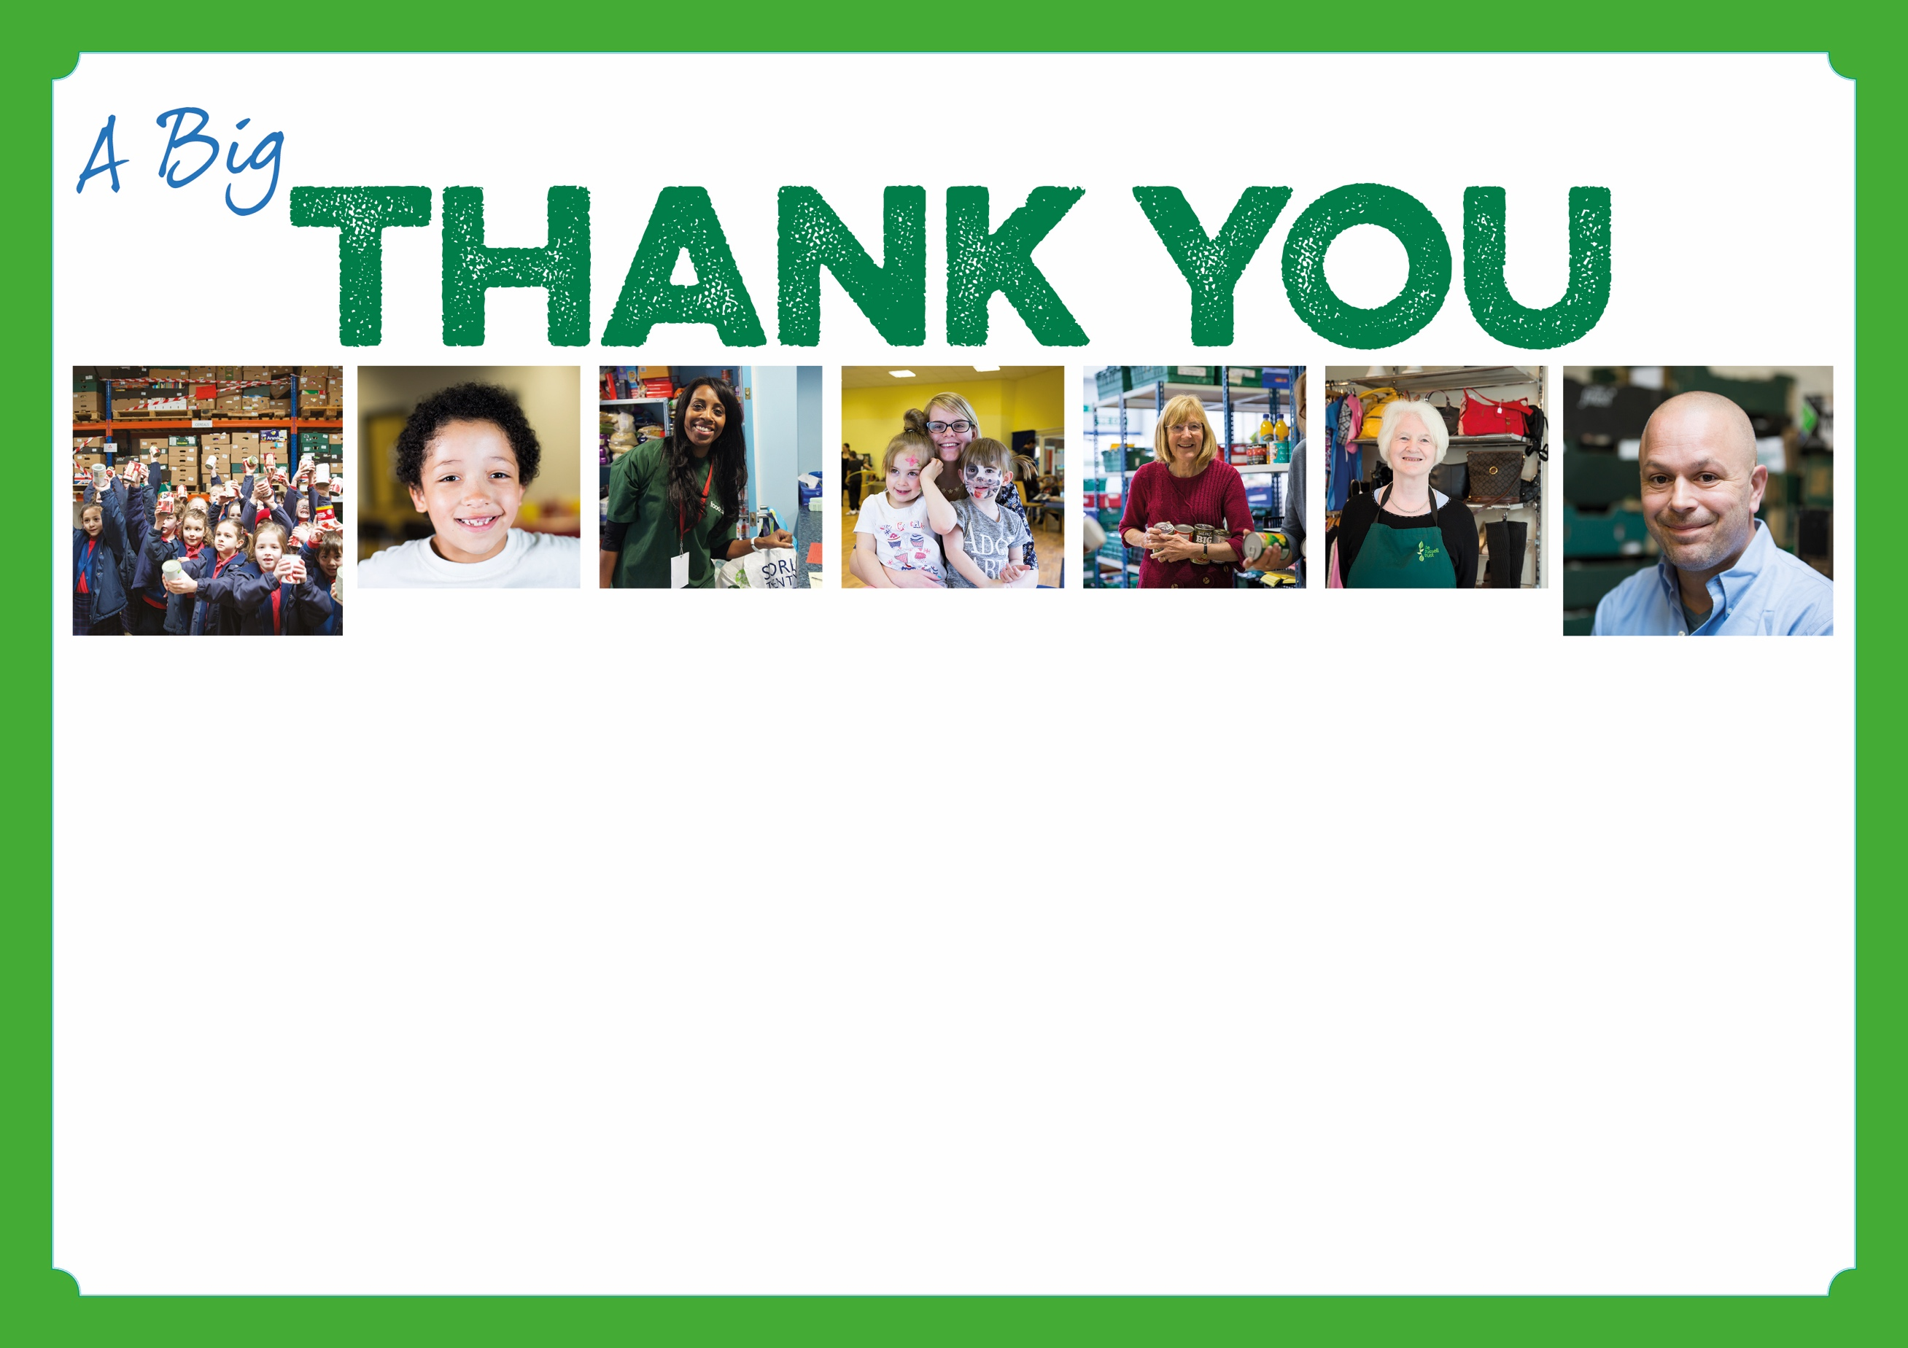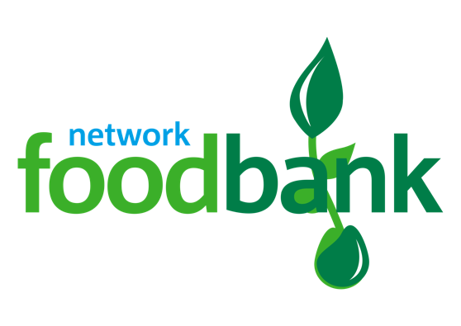

**Slade Primary School**

**Your donations make a BIG difference**

**to local people in crisis.**

**Erdington foodbank is part of the Trussell Trust’s UK wide foodbank network.**

**for supporting Erdington foodbank.**

Registered Charity Number: 1161641 | Registered in England and Wales