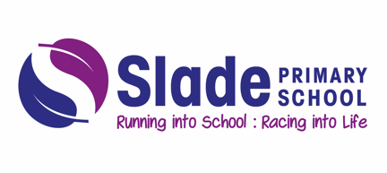
End of School Day
At Slade, we take the safety of our children very seriously. We have procedures and measures in place to guarantee everyone’s safety throughout the school day. You can read our full drop off and collection arrangements on the school website under Slade policies. Here is an overview of the end of day arrangements.
At the end of the school day:
- Parents are asked to queue in a single line, socially distanced at the relevant collection point.

- Children will be released to the parent/carer at the front of the parent line

- Classes are dismissed by their class teacher and teaching assistant from their designated gate or door

- All children say goodbye to their teacher and the class teacher checks that the parent or carer is here and watches the child meet their parent

- Children are released to parents and carers who we have had permission to do so. There may be times where we need to confirm this with the school office

- Where you require your child to be collected by another person who we do not have on file, please let the school office know as soon as is reasonably practical by telephone 0121 675 0618. If we have not been informed, we will phone to check before releasing your child. We appreciate this may delay you slightly but the safety of our children must take priority

- If you have not yet returned your form identifying adults that can collect your child and the home time password then please return this by Friday 14th May. After this date the school office will be contacting you. If you require another form, then please contact the school office on 0121 675 0618 or via email at enquiry@slade.bham.sch.uk

- Children in EYFS and KS1 will only be dismissed to a person over the age of 16

- Children in KS2 will be dismissed to a sibling of secondary school age (where agreed between the school and parent) or to their parent/carer

- We want to dismiss children as safely as possible. In order to do this, your patience is appreciated

- If you wish to speak to your child’s teacher, please wait until the class has been dismissed and then your child’s class teacher will be available. Alternatively, you can arrange an appointment through the school office on 0121 675 0618

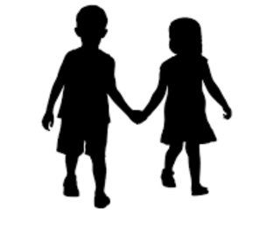
Thank you parents and carers for your patience and co-operation at home time.

