Monday 14th October 2024

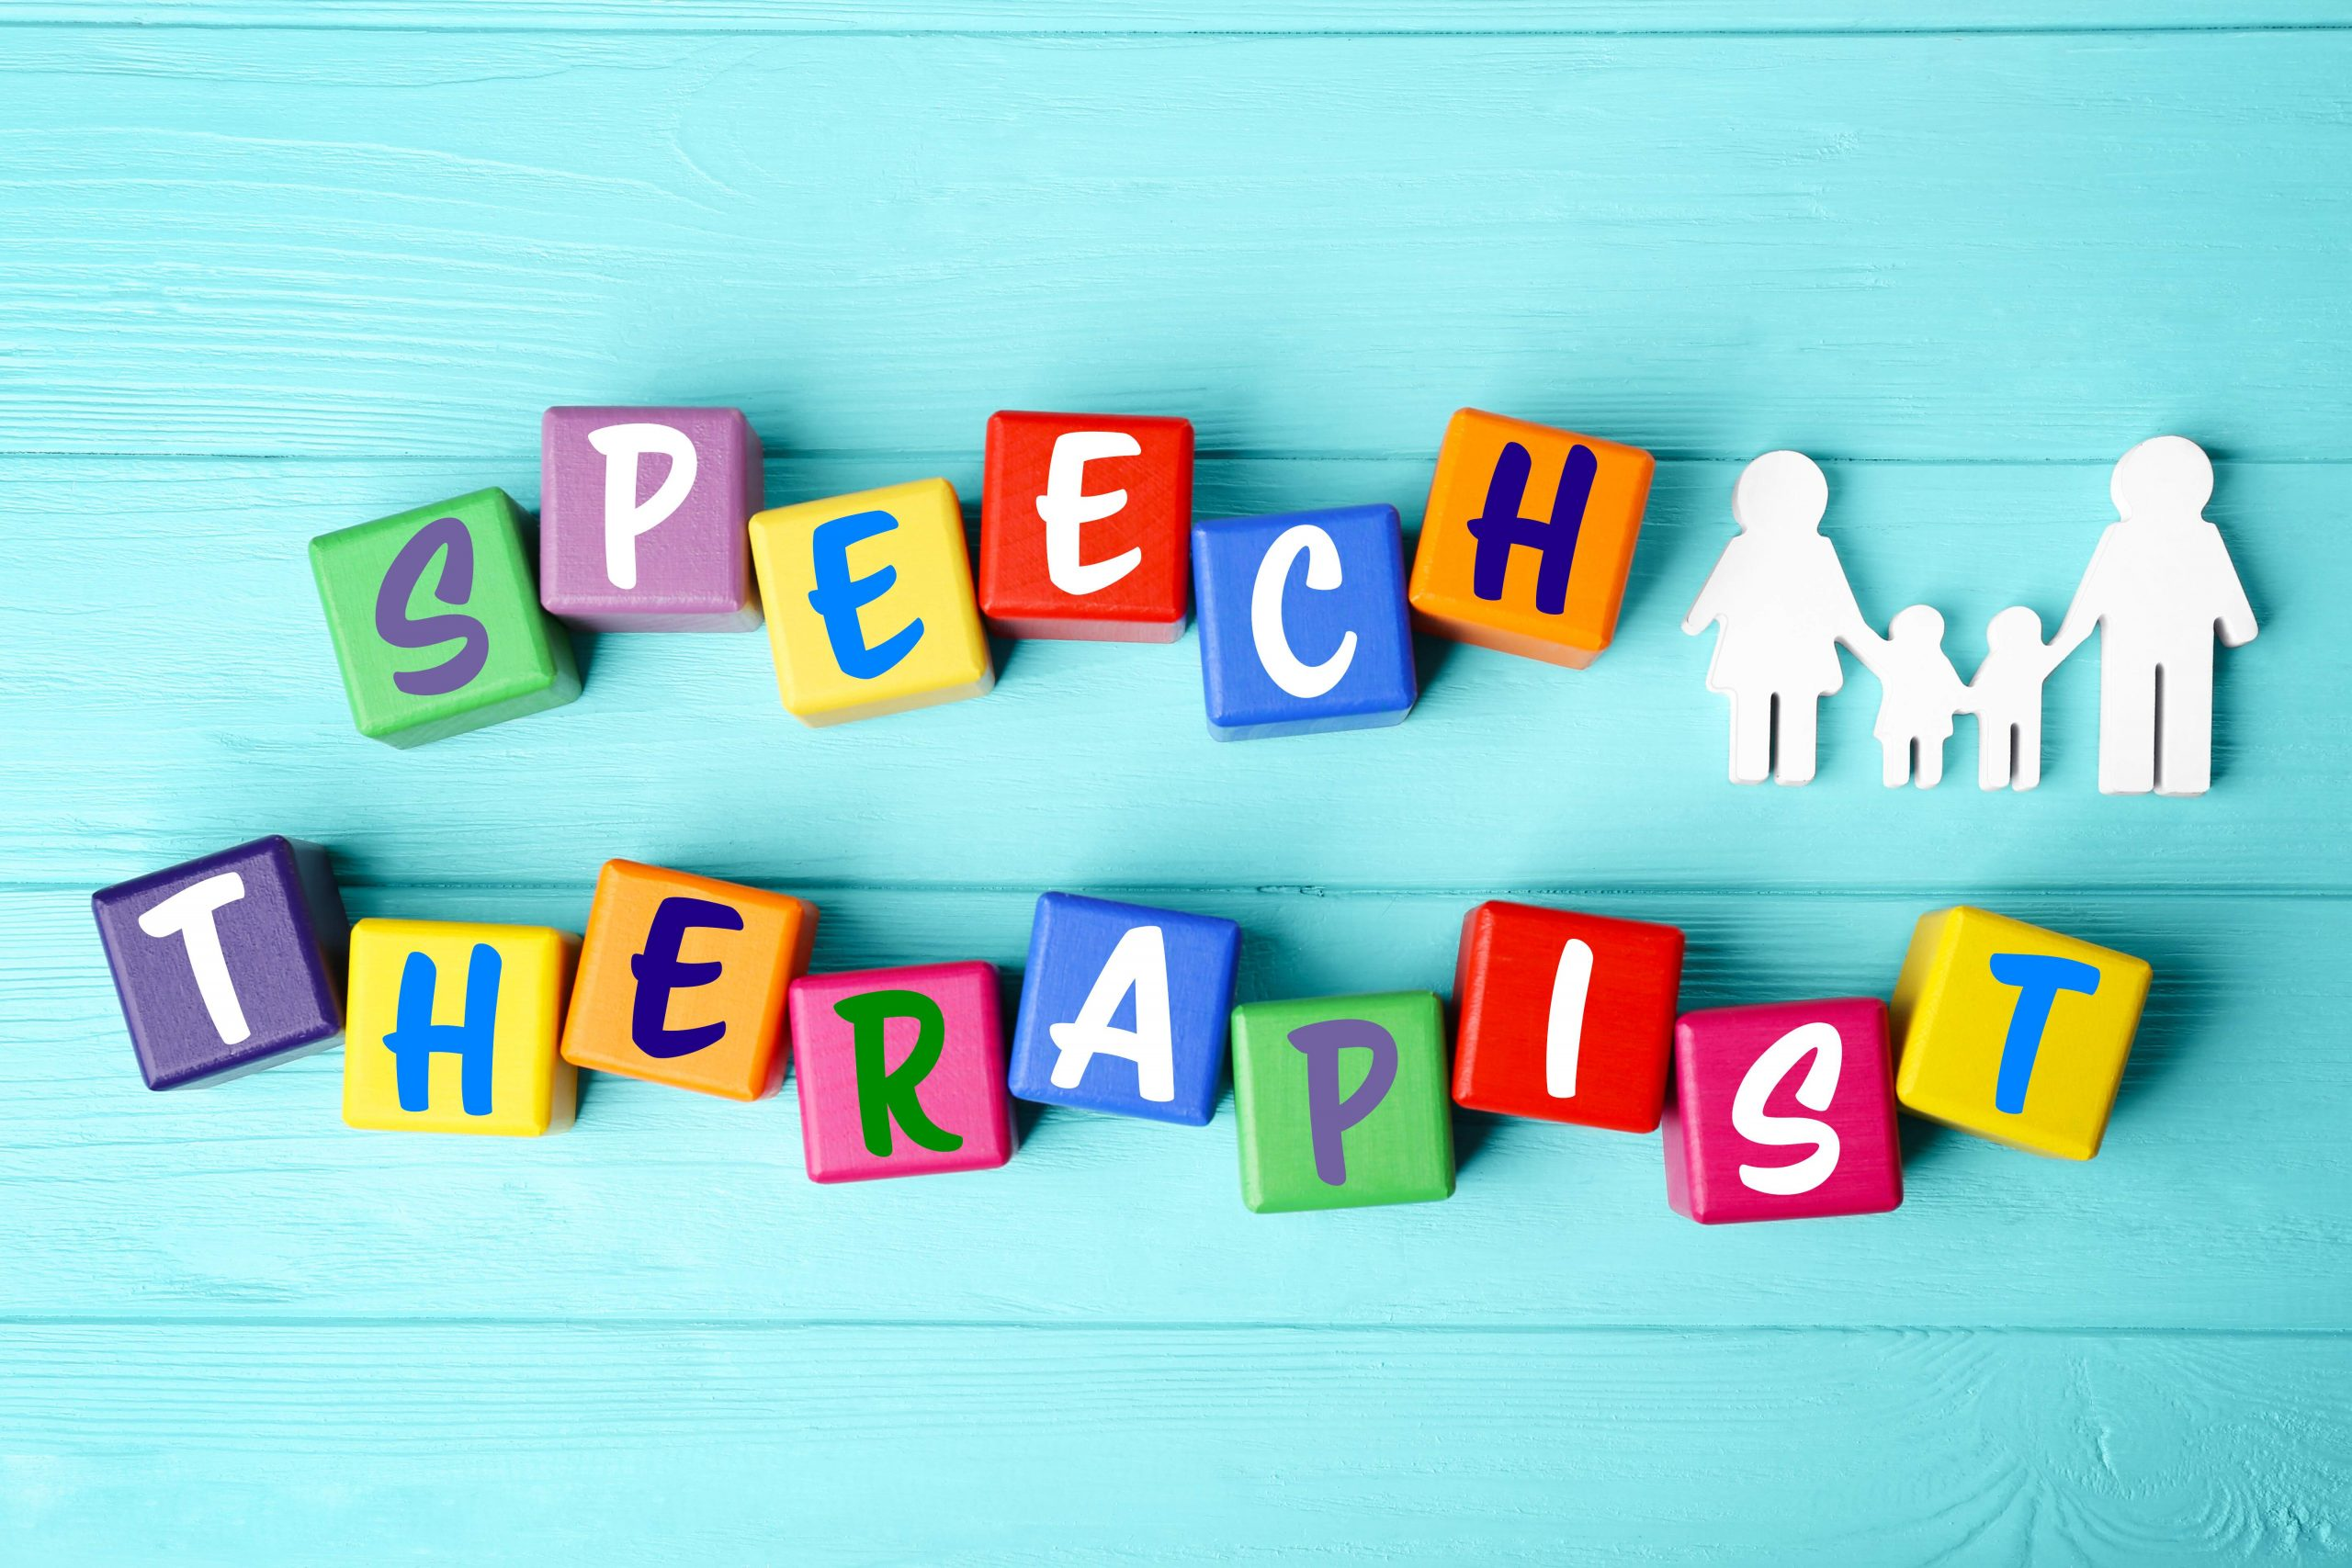

We are excited to be holding a workshop for families focused on understanding stammering and strategies for supporting children who stammer at home. The session will be led by our Speech Therapist

**Juliet Butler**

**9-10am**

**Monday 18th November** **2024**.

Refreshments will be provided. Please contacts the office if you wish to attend prior to this event by either telephone 0121 675 0618 or

